

**Student Support & Guidance**

**Summer 2021**

Dear Student,

As you know, as an impact of the Covid pandemic and subsequent national school closures, the Department for Education made the decision that the Summer 2021 examination series will not go ahead as planned. Instead, your teachers will determine your grades, based upon a wide range of evidence. Your teachers know you so well and are aware of your attainment and progress. They have your best interests at heart and will do all that the DfE and exam boards require to ensure that you are treated fairly during this time.

The teacher assessed grades that the school decides upon will be reviewed by the exam boards, alongside the supporting evidence that has been collected. This will all take place before the exam board award the final grades which reflect your performance on the content you have been taught. This will allow you to confidently progress to the next stage of your education and then into employment.

This booklet provides an overview of the most important information that you and your parents/ carers need to know about how grades will be awarded this Summer. This includes a timeline of what is happening and when, how teachers will determine your grades, when you will receive your results and the appeals process.

**What is happening and when?**

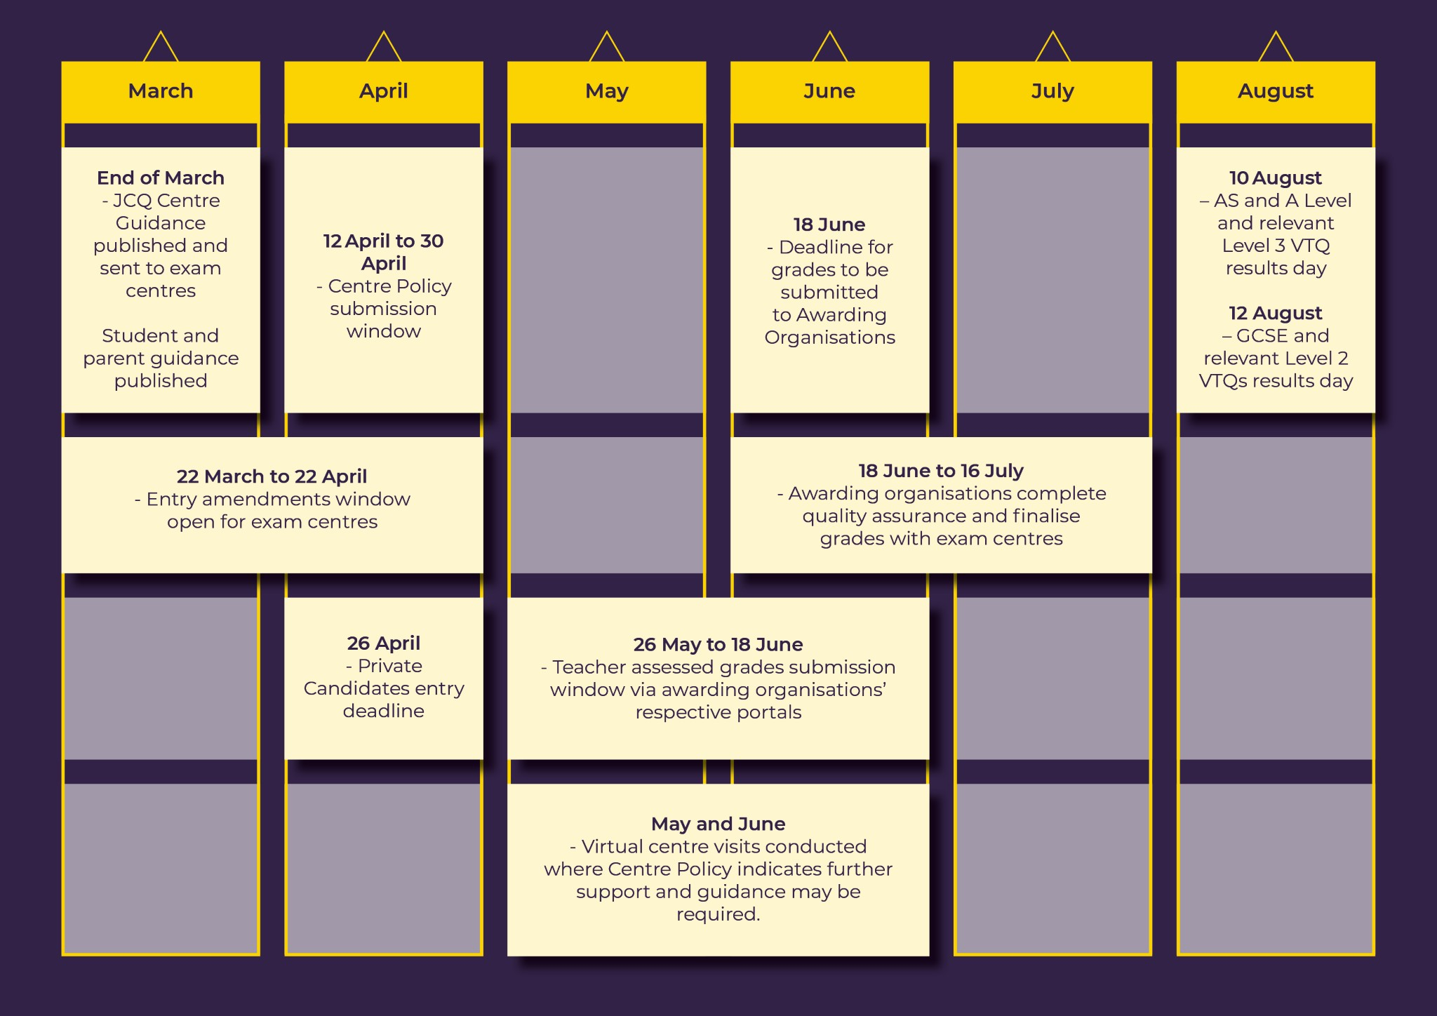

**How will I be assessed?**

Your teachers will initially determine your grades. They will then be reviewed by senior members of St Edward’s staff, so grades are determined consistently with the school’s policy (exam boards have checked and approved this policy to make sure it meets their requirements).

The professional judgement of teachers will only be based on what you have been taught and your teachers will use a range of evidence from across the course of study to make their decision.

Teachers can assess you based on:

• Records of your performance on the content you have been taught over the entire course of your studies;

• Non-exam assessment, often referred to as coursework or internal assessments, even if you have not fully completed it;

• Work you have produced in tasks set by your teachers that reflects the specification, format and marking of exam boards. This could include substantial classwork, homework, internal tests or mock exams;

• In-class assessments and assessments conducted under exam conditions.

Your teachers can develop these tests or use assessment materials provided by the exam boards. Importantly, these tests are not formal exams, nor are they designed to play the role of exams.

In most cases, the range of evidence that your teachers use to inform your grade will be consistent across your class or cohort for each qualification. However, we may decide that a different range of evidence is more appropriate to fairly inform your grade, if, for example, you have missed significantly more teaching than others in your class.

**Keeping you in the know**

Your teachers will tell you which pieces of work will be used as evidence to inform your overall grade. You will have the opportunity to raise any concerns about the evidence being used, for example, if the evidence was affected by personal circumstances, such as illness. Your teacher will make the final judgement about what evidence is to be included - this is not a negotiation. Your teachers will not be able to tell you the grade they have submitted to the exam board.

**How is the evidence used?**

No single piece of evidence will necessarily be more important than another, as teachers will be assessing you based on a range of evidence that can give an overall picture of your performance. Ofqual has issued separate guidance to schools, colleges and teachers about the submission of teacher assessed grades, including the evidence that can be used.

**Determining grades**

Once all the evidence is selected and assessments are complete, teachers will decide on an overall grade. They will do this objectively – so, if you are performing consistently at a grade B standard in a subject at A Level, you should be awarded a grade B.

It is important to say that, much like with exams in normal years, the grades issued by St Edward’s are not based on a summary of potential. Instead, they will be a snapshot of the standard you are performing at. This is based on a wide range of evidence. It should be no easier or harder for you to achieve a grade this year based on your performance than in previous years.

The process, as decided upon nationally by the DfE, Ofqual and exam boards is fair and takes into account the impact of the pandemic on your studies.

**What happens after my teacher determines my grade in a subject?**

Once your teachers have determined your grade, it will be reviewed by other teachers and senior members of staff at St Edward’s. This process of checking and approving grades ensures that the final submission is fair and accurate and applied consistently with our policy. Exam boards will check these policies to make sure they meet their requirements.

**Reasonable adjustments, access arrangements and special consideration**

If you have special educational needs, and/or are disabled, and require reasonable adjustments/access arrangements, the school should have ensured that these were in place when evidence was gathered. Where appropriate reasonable adjustments/access arrangements were not in place when you took an assessment that is being used as evidence, your teacher will take that into account when determining your grade. We could also consider whether other evidence could be used instead.

Special consideration requests will not apply in the usual way this summer because you will not be taking exams. If you think that your performance in an assessment has been affected by illness or personal circumstances, you should talk to your teacher about this as soon as possible. It is important that you raise any such instances before we submit your grade. If you have any questions about how your personal circumstances will be taken into account or want to raise anything with your teacher, now is the best time to speak to them. You should not wait until after you get your results.

**When will I receive my grades and what happens next?**

• AS and A Level students will receive their results on Tuesday 10th August 2021

• GCSE students will receive their results on Thursday 12th August 2021.

We will inform you of the plans for your results days in due course; all plans will take into account any Covid and social distancing measures which are still in place in August.

**Appeals (JCQ’s Appeals infographic can be found at the end of this booklet)**

Although everyone will be working hard to make sure you are issued with the correct grades on results day, there will also be an appeals system as a safety net to fix any genuine errors that were not identified earlier on. If you believe an error has been made in determining your grade, you will have a right to appeal.

**There are two stages to the appeals process:**

**Stage 1: Centre review**

If you don’t think you have been issued with the correct grade, you can appeal to the school to conduct a review into whether they:

• made an administrative error, e.g. they submitted an incorrect grade; they used an incorrect assessment mark when determining your grade;

• did not apply a procedure correctly, e.g. they did not follow their Centre Policy, did not undertake internal quality assurance, did not take account of access arrangements or mitigating circumstances, such as illness.

To help you decide whether to appeal, you can request that the school shares with you the following information on results day, if not before:

* their Centre Policy;
* the sources of evidence used to determine your grade along with any grades/marks associated with them;
* details of any special circumstances that have been taken into account in determining your grade, e.g. access arrangements, mitigating circumstances such as illness.

**Stage 2: Appeal to the exam board**

If you still don’t think you have the correct grade after the centre review is complete, you can ask St Edward’s to appeal to the exam board, who will review whether:

• St Edward’s made an unreasonable exercise of academic judgement in the choice of evidence from which they determined your grade and/or in the determination of your grade from that evidence (a reasonable judgement is one that is supported by evidence. An exercise of judgement will not be unreasonable simply because a student considers that an alternative grade should have been awarded, even if the student puts forward supporting evidence. There may be a difference of opinion without there being an unreasonable exercise of judgement. The reviewer will not remark individual assessments to make fine judgements but will take a holistic approach based on the overall evidence).

• St Edward’s did not apply a procedure correctly, e.g. they did not follow their Centre Policy, did not undertake internal quality assurance, did not take account of access arrangements or mitigating circumstances, such as illness.

• The exam board made an administrative error, e.g. they changed your grade during the processing of grades.

At both stages of the process you will need to submit your appeal to Ms Bridge (Exams Officer) at **exams@steds.org.uk** and give them your written consent to conduct the appeal or submit it to the exam board on your behalf.

**It’s important to remember that your grade can go down, up or stay the same through either stage of the process.**

If you have a place at university that is dependent on your appeal, you should tell the university you are hoping to go to so they can decide how to handle your offer. You should also tell Ms Bridge (Exams Officer) at **exams@steds.org.uk** so we can ask the exam board to prioritise your appeal.

The timelines for priority and non-priority appeals will be as follows:

* **10th August to 7th September**: priority appeals window
* 10th August to 16th August: student requests centre review
* 10th August to 20th August: centre conducts centre review
* 11th August to 23rd August: centre submits appeal to exam board
* **10th August to end October**: majority of non-priority appeals take place
* 10th August to 3 September: student requests centre review
* 10 August to 10 September: centre conducts centre review
* 11 August to 17 September: centre submits appeal to exam board

Finally, if you believe the exam board has made a procedural error in handling your appeal, you can apply to Ofqual’s Exam Procedures Review Service to review the process undertaken by the exam board.

**Useful Links:**

JCQ support & guidance for students/parents/carers can be found here:

<https://www.jcq.org.uk/summer-2021-arrangements/>

Edexcel/Pearson support & guidance for students/parents/carers can be found here: <https://qualifications.pearson.com/en/campaigns/summer-2021-support/support-for-students-parents-and-carers.html>

OCR support & guidance for students/parents/carers can be found here:

<https://www.ocr.org.uk/everything-you-need-to-know-for-summer-2021/students/>

AQA support & guidance for students/parents/carers can be found here:

<https://www.aqa.org.uk/student-and-parent-support>

Information including Ofqual’s *‘Student guide to awarding Summer 2021’* can also be found on our school website: <http://www.stedwardsacademy.co.uk/>

**If you have any questions please speak to your teachers, a senior member of staff or the exams officer.**

**If parents/carers have any questions please contact us:**

🕿 **01708 730462**

🖂[**info@steds.org.uk**](mailto:info@steds.org.uk) **/** [**exams@steds.org.uk**](mailto:exams@steds.org.uk)

